**FORMAN CHRISTIAN COLLEGE (A CHARTERED UNIVERSITY)**



**Information Security (COMP 421 - B)**

**Session: Fall 2023**

**Assignment 2**

**Laiba Nusrat**

**241549070**

[**TASK1**](https://www.offsec.com/metasploit-unleashed/port-scanning/)**:**

**Listing:**

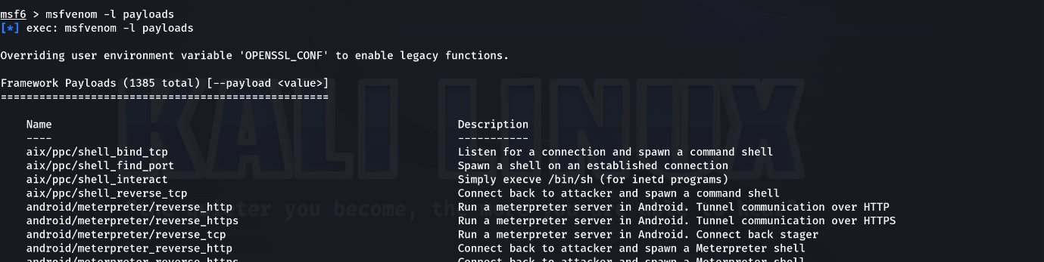

**Common params when creating a shellcode:**

**Windows**

**Reverse Shell:**

**Bind Shell:**

**Create User:**

**CMD Shell:**

**Execute Command:**

**Encoder:**

**Embedded inside executable:**

**Linux Payloads**

**Reverse Shell:**

**Bind Shell:**

**SunOS (Solaris):**

**MAC Payloads**

**Reverse Shell:**

**Bind Shell:**

**Web Based Payloads**

**PHP**

**Reverse shell:**

**ASP/x**

**Reverse shell:**

**JSP**

**Reverse shell:**

**WAR**

**Reverse Shell:**

**NodeJS:**

**Script Language payloads**

**Perl:**

**Python:**

**Bash:**

